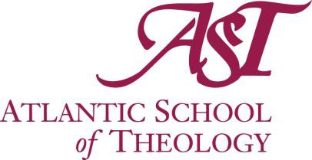

CALL FOR 2024 NOMINATIONS FOR HONOURARY DOCTOR OF DIVINITY DEGREE

Nominations:
The Honourary Degree Committee invites nominations from the members of the Atlantic School of Theology (AST) Senate, the Board of Governors, Founding Parties, students in-course and graduates. A maximum of two (2) appointments will be made in any year.

All submitted nominations are confidential. No approach is to be made to a candidate. If confidentiality is breached, the Honourary Degree Committee will not proceed with consideration of the candidate.

The Committee considers all received nominations and presents its selection(s) to Senate for approval. Once the President has contacted the recipient(s) and received confirmation of their acceptance, the names of recipients will be made public.

Criteria:
The AST honourary doctorate is awarded to persons who exemplify the ecumenical ethos of the university as reflected in our mission to serve by shaping faithful and effective ordained and lay leaders and understanding among communities of faith, and who would be perceived as bridge-builders. Bridge building may begin inside or outside of the specific faith traditions that are most central to the life of AST. The degree reflects the theological commitment of AST and our aspirational vision as a university that develops connections with different religious traditions and communities beyond.

AST may award the Doctor of Divinity honoris causa to persons whose public views are consistent with the ecumenical ethos, and who have made outstanding lifelong contributions in any of the following: church, community, business, public service, culture, arts and education.

Recipients will typically inhabit the Christian tradition, but they may also inhabit a different tradition. If possible, they will have local connections, but may also be honoured on the basis of national or international reputation. They should embody who we are, but may also help show us who we aspire to be.

Submissions:
Please make all nominations in writing, outlining the reasons for nomination and how the criteria of selection are met, to:

The Chair of the AST Honourary Degrees Committee c/o The President’s Office
Atlantic School of Theology 660 Francklyn Street
Halifax, Nova Scotia B3H 3B5
beth.pyesmany@astheology.ns.ca

Closing date for Nominations: January 10, 2024

Honourary Doctor of Divinity Recipient Nomination Form

Nomination Form

Individual Nominee’s name:___________________________________(Required)
Email and/or Phone:_______________________________________________________________

Nominator’s name:
Email:________________________________________________________________

Address:

City/Town: Province:

Postal Code: Phone:

- We may contact you for information or clarification regarding your nomination.
- The information collected through the application process will be used only to determine the recipient of the Honourary Doctor of Divinity.

Nominator’s Signature: Date:

Please ensure your nomination follows the criteria outlined above. Please limit the nomination to one page.

